DATA STRUCTURES AND ALGORITHMS
Exercise 2: E-commerce Platform Search Function
Scenario:
You are working on the search functionality of an e-commerce platform. The search needs to be optimized for fast performance.
CODE:
import java.util.Arrays;
import java.util.Comparator;

public class Product {
private int productId;
private String productName;
private String category;

public Product(int productId, String productName, String category) {
this.productId = productId;
this.productName = productName;
this.category = category;
}

public int getProductId() { return productId; }
public String getProductName() { return productName; }
public String getCategory() { return category; }

@Override
public String toString() {
return "Product{" + "id=" + productId + ", name='" + productName + "', cat='" + category + "'}";
}

public static Product linearSearch(Product[] products, int targetId) {
for (Product product : products) {
if (product.getProductId() == targetId) {
return product;
}
}
return null;
}

public static Product binarySearch(Product[] sortedProducts, int targetId) {
int left = 0;
int right = sortedProducts.length - 1;

while (left <= right) {
int mid = left + (right - left) / 2;
int midId = sortedProducts[mid].getProductId();

if (midId == targetId) {
return sortedProducts[mid];
}
if (midId < targetId) {
left = mid + 1;
} else {
right = mid - 1;
}
}
return null;
}

public static void main(String[] args) {
Product[] inventory = {
new Product(105, "Wireless Mouse", "Electronics"),
new Product(101, "Running Shoes", "Footwear"),
new Product(104, "Coffee Mug", "Kitchen"),
new Product(102, "Leather Wallet", "Accessories")
};

System.out.println("--- Linear Search ---");
Product res1 = linearSearch(inventory, 104);
System.out.println("Found: " + res1);

Product[] sortedInventory = Arrays.copyOf(inventory, inventory.length);
Arrays.sort(sortedInventory, Comparator.comparingInt(Product::getProductId));

System.out.println("\n--- Binary Search ---");
Product res2 = binarySearch(sortedInventory, 104);
System.out.println("Found: " + res2);
}
}
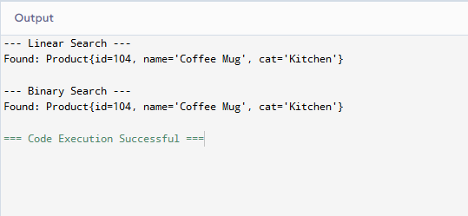
Exercise 7: Financial Forecasting
Scenario:
You are developing a financial forecasting tool that predicts future values based on past data.
CODE:

public class FinancialForecasting {

public static double calculateFutureValue(double presentValue, double growthRate, int periods) {

if (periods <= 0) {
return presentValue;
}

return calculateFutureValue(presentValue, growthRate, periods - 1) * (1 + growthRate);
}
public static void main(String[] args) {
double initialInvestment = 1000.0;
double annualGrowthRate = 0.05;
int years = 4;

System.out.println("--- Financial Forecasting Simulation ---");
System.out.printf("Initial Principal: $%.2f%n", initialInvestment);
System.out.printf("Expected Growth Rate: %.1f%%%n", (annualGrowthRate * 100));
System.out.printf("Forecast Horizon: %d years%n", years);

double forecastedValue = calculateFutureValue(initialInvestment, annualGrowthRate, years);

System.out.println("----------------------------------------");
System.out.printf("Forecasted Future Value: $%.2f%n", forecastedValue);
}
}
